Project Design Phase-II

Technology Architecture

|  |  |
| --- | --- |
| NM_ID | BF65628C5F4C176991E4180F64CA6B6F |
| ProjectName | How to Create Brand Name, Brand Mail and Brand Logo in Canva |

# Technical Architecture:

The Deliverable shall include the architectural diagrams below and the information as per the table1 & table2

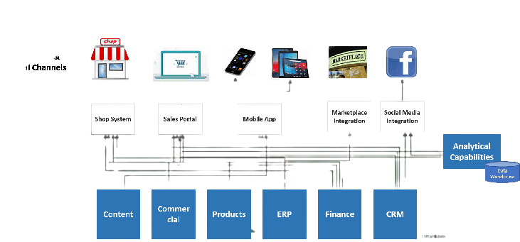

# Table-1: Components &Technologies:

|  |  |  |  |
| --- | --- | --- | --- |
| **S.No** | **Component** | **Description** | **Technology** |
| 1. | Branding Tools | Implement design software and tools for logo creation, email template development, and brand name generation. This includes graphic design software, email server software, and domain registration tools. | graphic design software |

|  |  |  |  |
| --- | --- | --- | --- |
| 2. | Cloud Hosting and Servers | Host your website and client data in the cloud, providing scalability, redundancy, and accessibility. Utilize cloud services like AWS, Google Cloud, or Azure for flexibility. | AWS |
| 3. | Data Storage and Databases | Store client data, project files, and branding assets in a secure database. Implement data encryption and regular backups to ensure data integrity and security. | secure database |
| 4. | Compliance and Security Documentation | Maintain comprehensive documentation on security protocols, compliance measures, and data protection policies to reassure clients about the safety of their data. | security protocols |
| 5. | Scalability Solutions | Set up systems that allow for easy scalability, such as auto-scaling for cloud resources, load balancing, and monitoring for performance optimization. | cloud resources |

**Table-2:Application Characteristics:**

|  |  |  |  |
| --- | --- | --- | --- |
| **S.No** | **Characteristics** | **Description** | **Technology** |
| 1. | Social Media Integration | Enable clients to share their newly created brand identity elements on social media and integrate with popular social platforms for marketing purposes. | social media |

|  |  |  |  |
| --- | --- | --- | --- |
| 2. | Feedback and Review System | Implement a system for clients to provide feedback and leave reviews, helping your business gather insights for continuous improvement. | Google reviews |
| 3. | Performance Optimization | Regularly monitor and optimize the application's performance to ensure fast loading times and a smooth user experience. | Technology used |
| 4. | Localization and Multilingual Support | If serving a global audience, provide options for localization and multilingual support to accommodate clients from different regions. | Technology used |